SCHOOL OF COMPUTER SCIENCE AND ARTIFICIAL INTELLIGENCE |  |  |  |  | DEPARTMENT OF COMPUTER SCIENCE ENGINEERING
Program Name: M. Tech/MCA |  |  |  | Assignment Type: Lab |  |  | AcademicYear:2025-2026
Course Coordinator Name |  |  |  | Venkataramana Veeramsetty
Course Code |  |  | 24CS002PC215 | Course Title |  | AI Assisted Problem Solving Using Python
Year/Sem |  |  | I/I | Regulation |  | R24
Date and Day  of Assignment |  |  | Week1 - Tuesday | Time(s)
Duration |  |  | 2 Hours | Applicable to  Batches |  | M. Tech/MCA
AssignmentNumber:03.3(Present assignment number)/24(Total number of assignments)
 | Q.No. | Question |  |  |  |  |  | ExpectedTime  to complete
 | 1 | Application for TGNPDCL  Objective: Build an application using Python program for TGNPDCL, to generate the bill based on energy consumption and type of customer with the help of AI tools.  Build a python application as per below instructions  - Read all the required data like PU,CU and Type of customer  - Calculate bill amount based on number of units consumed, type of customer and other charges  - Finally print the values of EC(Energy Charges),FC(Fixed Charges),CC(Customer Char-ges),ED(Electricity Duty Charges),bill as per expected output  Requirements:  - VS Code with Github Copilot and/or Google Colab with Gemini  - Students should bring power bill from their home  Deliverables:  - Print energy bill for given inputs and verify with bill taken by students  PROMPT-1:  Read all the required data like PU,CU and Type of customer. Calculate bill amount based on number of units consumed, type of customer and other charges.Finally print the values of EC(Energy Charges),FC(Fixed Charges),CC(Customer Char-ges),ED(Electricity Duty Charges),bill as per expected output  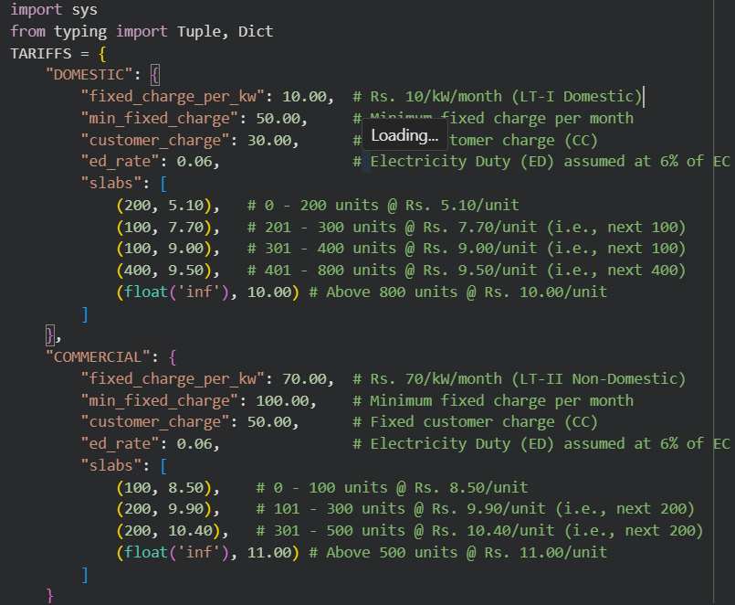  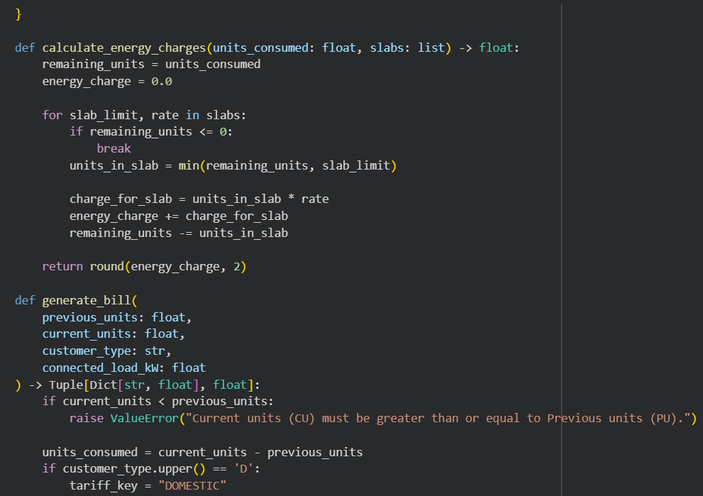  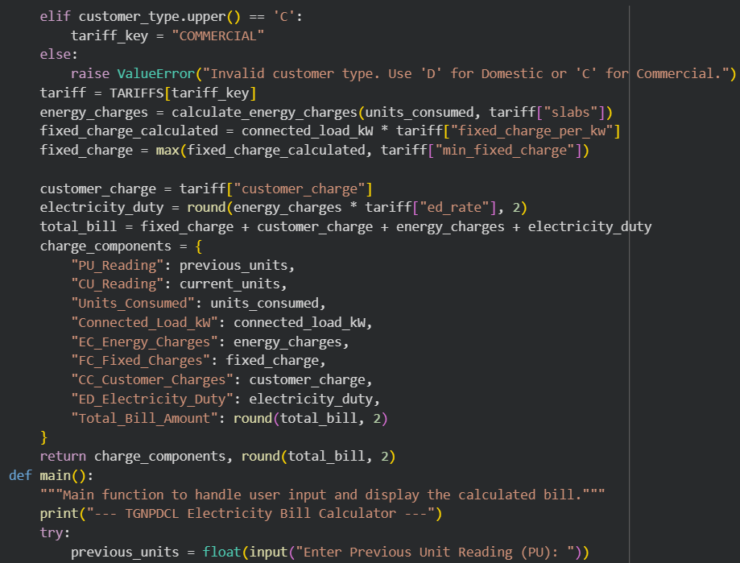  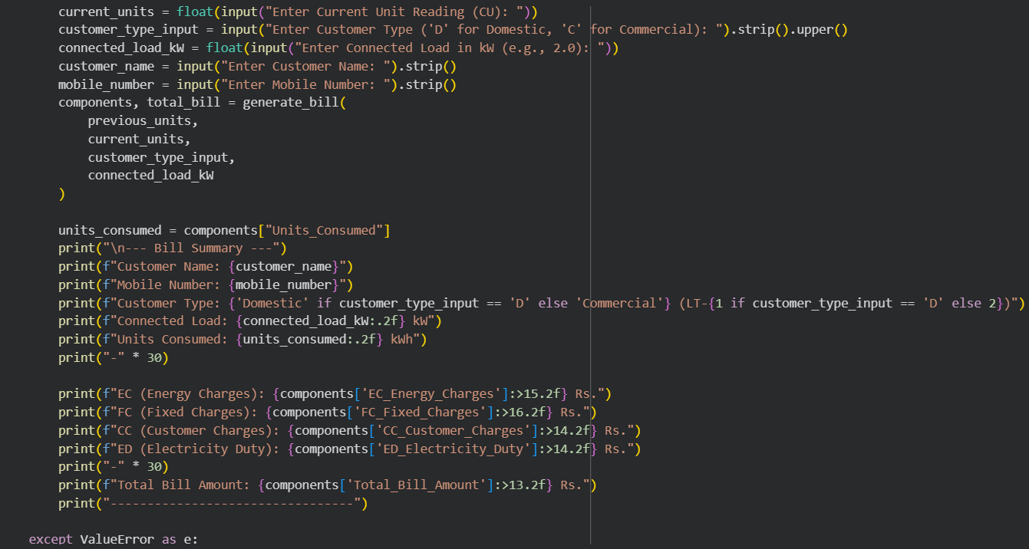  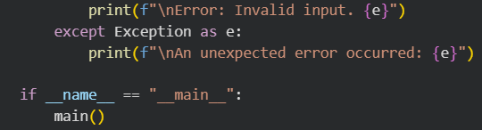  OUTPUT:  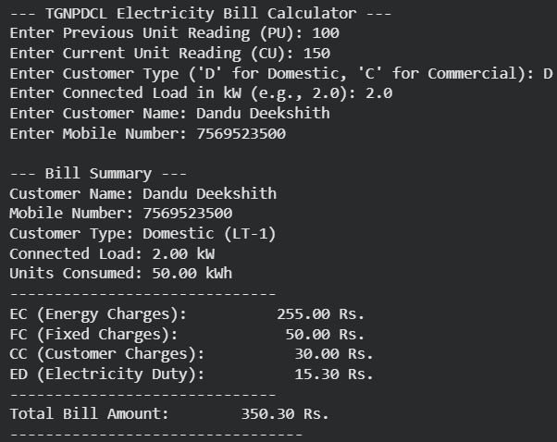 |  |  |  |  |  | Week2 - Wednesday

